Official Invitation to Compete
USPSA Match: 2022 Battle for the North Coast
Ohio North Section Championship
Hosted by Crooked Creek Pistol League
Name Match Dates: August 19-21, 2022
Address
Address 2
Congratulations, Name,
You are cordially invited to participate in the practical shooting match run by the Crooked Creek Pistol League of Crooked Creek Conservation Club, which is located at 4323 State Route 534, Hartsgrove, OH 44085, on the following dates: August 19-21, 2022.
DO NOT DISCARD THIS LETTER. As a visitor to the United States, you will need this letter to qualify for a “Form 6” import permit allowing you to bring your firearms into the United States. You will be asked to present an itinerary and may be asked to show your USPSA or IPSC-affiliate membership card (we suggest you attach copies of both to your Form 6 application). As a competitor, you qualify for the sport shooting exemption that allows a foreign national to posses a firearm while attending shooting events in the United States.
According to the Bureau of Alcohol, Tobacco, and Firearms (BATF) you must submit a copy of this letter, along with your Form 6 application to the BATF Import Branch in Washington, D.C. prior to your travel dates. A separate Form 6 is needed for each event you attend. Please pay close attention to this requirement while traveling in our country.
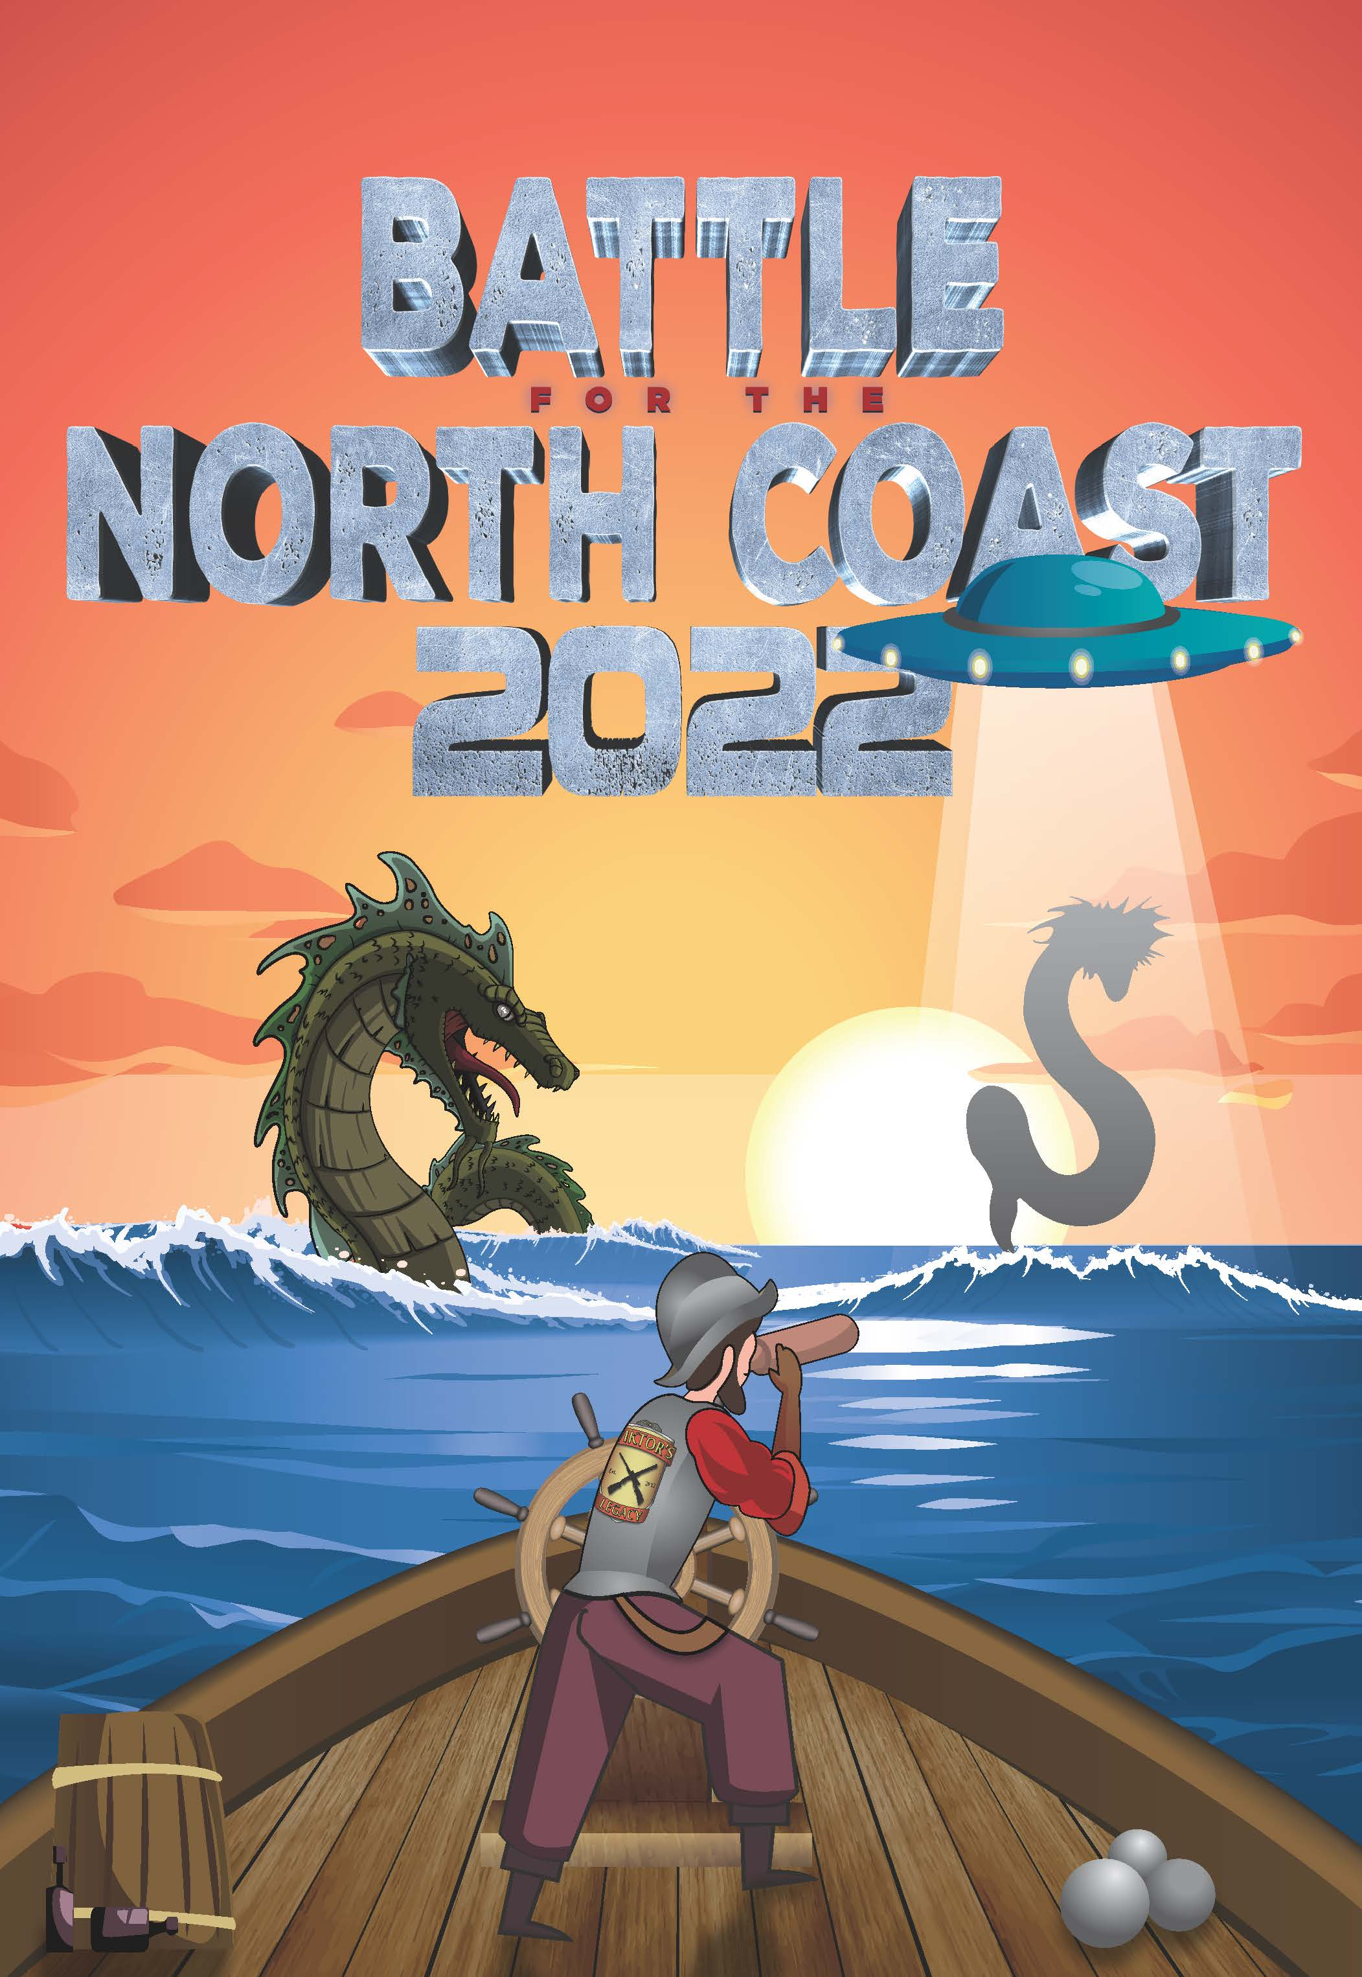For more information on the import process, go to https://www.atf.gov/firearms/docs/form/form-6nia-applicationpermit-temporary-importation-firearms-and-ammunition and https://www.atf.gov/firearms/qa/what-documentation-does-alien-need-show-us-customs-and-border-protection-cbp-when
If you have further questions, please contact us at the number or email
address listed below. We look forward to seeing you soon.
Match Registration: Bud Connolly
Home Phone Number: 440-259-3512
e-mail: registration_battle@practicalpistol.net

